INTRODUCTION
​‍​‌‍Public​‍​‌‍​‍‌​‍​‌‍​‍‌ transportation has always been one of the most important factors in the existence of a modern society, being the main tool for mobility, economic growth, and sustainable urbanization. Nevertheless, in several developing and semi-urban areas, the quality of transport systems is still greatly affected by problems such as inefficiency, lack of transparency, and poor technological integration. In small cities and rural areas, people usually face situations of buses with unpredictable schedules, overcrowded vehicles, limited ticketing infrastructure, and the total absence or near-complete absence of real-time information. These problems not only make the lives of commuters more difficult but also cause transport authorities to have operational inefficiencies which in turn lead to waste of fuel, poor resource allocation, and a decrease of the public's trust in the transport system.
Public Transport Tracking and Management System is a new intelligent platform which through AI-based analytics, real-time GPS tracking, digital ticketing, and route optimization integration offers a unified web-based ecosystem to overcome the above-mentioned problems. By employing machine learning (ML) and data-driven automation, the system is a major step forward in the digital transformation of the public transport sector whereby the organization and execution of daily transport operations take place with higher accuracy, speed, and convenience. The platform has been planned and built as a full-stack web platform that in real time connects commuters, drivers, and administrators—thus, cutting the traditional link between on-ground operations and central management systems.
Lately, public transport has been managed manually with very low-tech tool usage especially in developing countries. Everything such as route planning, fare collection, and vehicle allocation was done either on paper or through very old systems which gave little real-time fleet activity visibility. Inaccurate timetables, absence of vehicles, delayed communication between passengers and drivers, and deteriorating data records were some of the main results of the inefficiencies mentioned. The rising population together with the urban growth of tier-2 and tier-3 cities has even magnified these problems making a smart, data-based solution necessary. The system proposed is a direct response to the problems faced in public transport through the use of an AI-based predictive engine that enables live location tracking, ETA prediction, and operational analytics.

Besides being prepared for the future growth and expansion, the system is such that would still appeal even if highly urbanized areas were fully equipped with advanced smart-transport systems. Small and medium-sized cities are still lacking affordable solutions that would be efficient with few infrastructures and an unstable network. The Public Transport Tracking and Management System closes the distance between these two worlds by providing an offline-first, cloud-supported architecture that is still workable in low-connectivity areas. The adoption of this platform particularly targets a large number of third-world countries where a good portion of the population without cellphones or fast internet will be still able to receive essential transport information through SMS or IVR (Interactive Voice Response) services.
Artificial Intelligence plays a major role in this system. The AI microservice on the platform makes use of machine-learning regression models which are trained using real-time data (including traffic density, distance, and weather) for each route to determine the most accurate arrival times. Then it also integrates crowd-density estimation models based on historical ridership and passenger feedback to support the comfort and safety of passengers. Gradually, the equipment studies and evolves—becoming more efficient and accurate as it gathers more operational data. Such a self-improvement model enables transport authorities to control the routes before the event, forecast rush hours, and make the best use of their resources to reduce traffic and most of their vehicles sitting idle.
Together with the real-time tracking and analytics, the system is also emphasizing on the digital ticketing and cashless payments. Users can easily reserve and pay for their rides through the web interface if there is a contactless digital ticketing system integrated into the platform. The platform is compatible with different payment methods and it also ensures that the transactions are secure by using PCI-compliant encryption. The work of drivers gets less strenuous and goes faster as a result of this, and if we look at things from the side of administrators, they get a tool for effortless revenue recording and transparent auditing. The digitalization of the system leads to the minimization of mistakes, prevention of revenue theft and, in general, contributes to the overall reliability of the system.
Such technology became even more significant during and after the COVID-19 pandemic that disrupted transportation all over the world and showed the need for contactless, data-driven systems. With the world rapidly moving towards smart cities and digital governance, having an adaptable, AI-powered transport platform is no longer a matter of choice, but a necessity. The system being suggested helps the United Nations Sustainable Development Goals (SDGs) in different ways, most notably Goal 9 (Industry, Innovation, and Infrastructure), Goal 11 (Sustainable Cities and Communities), and Goal 13 (Climate Action). By becoming more efficient and using public transport more, it lowers the emissions from vehicles and thus helps clean urban development.
The​‍​‌‍​‍‌​‍​‌‍​‍‌ Public Transport Tracking and Management System is a perfect integration of user-friendly web features with cutting-edge predictive AI and cloud computing technology. The project is not a heavy metal one and doesn't require an excessive number of IoT devices. Instead, it relies on the current smartphones, GPS-enabled dashboards for drivers, and Internet-based APIs for data collection and processing. As a result, it is pretty easy and cheap to put into practice by local government officials and the private sector as ​‍​‌‍​‍‌​‍​‌‍​‍‌well.
Summing up, the system is a scalable, secure, and eco-friendly approach to tackling the challenge of upgrading public transport infrastructure. It restructures an old, fragmented network into a smart digital system capable of real-time monitoring, AI-based forecasting, and user engagement. The system, by giving a hand to the public transport authorities to remove inefficiencies in operations and also addressing the grievances of the commuters, thus, coming up with a new definition of public transport as a transparent, accessible, and future-ready ​‍​‌‍​‍‌​‍​‌‍​‍‌service.​‍​‌‍​‍‌​‍​‌‍​

OBJECTIVES OF THE PROJECT
The​‍​‌‍​‍‌​‍​‌‍​‍‌ primary goal of this endeavor is to implement a layered public transit management framework powered by AI that is not only efficient from an administrative perspective but also makes the whole commuting scenario favorable. The project outlines several specific objectives such as: ​‍​‌‍​‍‌​‍​‌‍​‍‌
- To​‍​‌‍​‍‌​‍​‌‍​‍‌ allow real-time tracking of buses and other vehicles using live GPS data and show their locations to the users on an interactive map interface.
- To build AI-based ETA prediction models that calculate the arrival time with great precision by using the real-time traffic, distance, and weather data.
- To implement​‍​‌‍​‍‌​‍​‌‍​‍‌ a digital ticketing and payment system that allows users to purchase their tickets online and receive them in the form of safe, verifiable e-receipts.
- To provide a driver interface for receiving route updates, recording attendance, and communicating the live operational status to the control center.
- To develop an admin dashboard for the efficient management of routes, vehicles, key performance indicators, and data analytics from a single location.
- To equip the fleet with crowd-density estimation and anomaly detection technologies that promote the safety of the commuters and the quality of the ​‍​‌‍​‍‌​‍​‌‍​‍‌fleet.
- To enable multichannel access through the web, SMS, and IVR so that users without a smartphone can also get real-time updates.
- To encourage eco-friendly, cheap, and sustainable transport measures that lead to less congestion and saving of fuel.
- To take care of data security and scalability by means of encrypted, cloud-deployed microservices that use a containerized ​‍​‌‍​‍‌​‍​‌‍​‍‌infrastructure.
Collectively, these objectives serve as a blueprint for the overhaul of conventional transport operations through the application of AI at the core of mobility ​‍​‌‍​‍‌​‍​‌‍​‍‌management.

DESCRIPTION OF THE PROJECT

The​‍​‌‍​‍‌​‍​‌‍​‍‌ Public Transport Tracking and Management System is an interconnected, smart, web-based solution that aims to change the way transport networks are managed, tracked, and optimized in small and medium-scale cities. Essentially, the system operates as one digital ecosystem that is able to merge the needs, requirements, and activities of commuters, drivers, and transport administrators in real-time, thus, providing a result of transparency, accountability, and efficiency of operations. The system is a combination of several cutting edge technologies i.e. artificial intelligence, machine learning, data analytics, and cloud computing to name a few, and the result is a smart, scalable, and reliable system that can work even in low network areas and still give high performance.

The main goal of the platform is to create a durable and inclusive public transit system with a live tracking feature, in addition to this, it will also use predictive modeling techniques based on data collected to not only predict bus arrival times but also to implement digital ticketing management and to assist in the implementation of green transport measures. The platform has been designed as a full-stack web application using AI microservices and modular components,

thus, making it adaptable and capable of meeting the requirements of future smart-cities. Its creation has been guided by a distributed architecture concept where the backend, frontend, and AI modules communicate with each other through APIs, thereby creating an uninterrupted data flow between commuters, drivers, and administrators.

They have been mostly stuck with the same old transportation methods in the developing areas, where public transport scheduling is inefficient due to the fact that it is all done manually and data-handling is also manual, and this is where the idea of the project comes from. Most of the time, bus networks just rely on physical timetables and depot managers and drivers communicate manually, and due to these things, there are always delays, buses are overcrowded, and passengers become angry. Lack of up-to-date information also results in passengers becoming unable to plan their trips properly, which, in turn, causes irregularity of passenger distribution and inefficient use of fleet capacity. To break out of these constraints, the system is equipped with an AI-based architecture solution that will be capable to gather, process, and interpret real-time transport data for the purpose of decision-making in a smarter way.

Fundamentally, the backend server, which is developed by utilizing Node.js and Express.js, is the brain of the whole thing that keeps the records, carries the route logic, and manages the interaction between different parts of the project. The system and user-related data of all the users are kept safely inside a MongoDB database, where different collections work as the managers of data such as users that have logged in, driver profiles, route definitions, booking records, and of course, the locations of vehicles where the data are released in real time. The backend part also cooperates with a few external agencies like Google Maps API, OpenStreetMap, and payment gateways to offer services in the fields of navigation, mapping, and digital transactions respectively. In fact, every move that a user does—from purchasing a ticket to getting an AI-generated prediction—is a result of issuing RESTful API calls, which is a way to realize the communication between the client and the server in real time.

The frontend interface, created with React.js and TailwindCSS, is an appealing and user-friendly platform which lets users of public transport systems have a seamless interaction with the system. This is a user-friendly responsive web portal through which a passenger can carry out all the work with ease such as access their account, find the routes for buses, get the measure of

punctuality of the arrival to the stops, moreover, they can track vehicles in real-time on the map by linking it to the local transport system. In fact, the work carried out in the area of design is accessible and light, which means that it is possible to use it from both the desktop and mobile device without the high demands of the network being an issue thereby people in low band areas will still have access to essential features and the need for a dedicated mobile application will be redundant. Besides that, the interface is at par with the best accessibility features like color themes of high contrast and also keyboard navigation that makes it suitable for the blind and visually impaired users.

Driver module is facilitated with an easy-to-understand dashboard where they log their attendance, update route progress, and share the current location of the vehicle with the control center. Drivers have the ability to physically demonstrate at the moment when a trip starts and ends using a web interface, thus, it guarantees that all journeys are documented and can be followed. Through these continuous GPS notifications, the backend is able to get updates on drivers or commuters through the use of WebSocket communication lines which facilitate live interchanges of location changes on the driver and admin dashboards. The driver module also comes with an alert feature that can be used to send the news of the emergency or technical problem on the way and thus safety and accountability become more ​‍​‌‍​‍‌​‍​‌‍​‍‌promoted.‌

The​‍​‌‍​‍‌​‍​‌‍​‍‌ administrative dashboard is the main tool of the transport authorities. This one-stop window shows the entire system operation at a glance with features such as live fleet tracking, route analytics, and financial overviews. Admins have the power to control vehicle assignments, change schedules, and keep an eye on metrics such as avg travel time, passenger load, or ticket sales through the dashboard. The platform uses immediate graphs and heatmaps to illustrate these data points which allow for data-driven decision-making. Besides that, there is an option to prepare automated reports for auditing and performance assessment purposes which is a great time saver for the rest of the staff.

The AI microservice is the brain of the system, and it is designed as a separate backend unit crafted in Python and FastAPI. This service consists of multiple machine-learning models, with each being solely responsible for one specific task. The ETA model utilizes regression algorithms that take in GPS coordinates, historical route data, and even traffic and weather

conditions to come up with extremely accurate bus arrival time predictions. For its part, the route optimization model relies on graph-based algorithms like Dijkstra’s Algorithm and A* Search to work out the shortest routes between stops in a way that not only saves time but also fuel. Meanwhile, the crowd density estimation module is actively using the latest data as well as checkins to determine the level of crowding in a bus or at a station at a particular time thus enabling both the passengers and the administrators in better planning.

Without exception, all these models get updated with fresh data coming from the system’s historical records of operation. Thanks to the adoption of a self-learning architecture, the platform gets better and faster with each subsequent interaction, constantly adapting to new traffic conditions, seasonal changes, or redirects. Moreover, the incorporation of AI in the daily transport workflow is not only instrumental in lessening the workload of human overseers but also in making the operations more predictable and efficient.

Perhaps, a most outstanding attribute of the platform is its focus on digital ticketing and secured payments. The ticket reservation feature grants users with online seat booking capabilities followed by the payment through the likes of credit cards, digital wallets, or UPI. PCI-DSS compliant security measures are in place for every transaction which goes through the encrypted channels, thus assuring the safety of money. After the successful transaction, a digital ticket is made and saved in the user’s profile plus a duplicate is sent by email or SMS. The adoption of digital ticketing has several advantages: firstly, the abolition of paper tickets; secondly, the quick boarding of passengers; and lastly, the authentic revenue records which are transparent to the administrators thus leaving little room for fraud or leakage.

Where there’s a will, there’s a way. An equally important functionality is the alert & notification program that guarantees timely communication between the platform and its users. So, passengers get notified about schedule changes, delays, or route diversions instantly through email, SMS, or push notifications. The drivers receives alerts from the system regarding their assigned trips or maintenance checks, and administrators get automatic notifications about the occurrence of unusual activities such as stopping for a long period or driving off-route. All these interconnected notification system components work to make the whole transport network more responsive.

The project also embraces sustainability and inclusivity not only in the designs but as the core guiding principles as well. The lack of smartphones and consistent internet access is something that is common among most of the rural and semi-urban commuters. To overcome this hurdle, the platform comes up with other options like SMS-based query responses and IVR services that act as a bridge connecting transport services and users irrespective of the latter’s digital literacy level. These offline-first approaches are a guarantee that the provision of information will not be confined by infrastructural gaps which, in turn, make the project compatible with the national digital-inclusion objectives.

Technically, the whole setup revolves around a containerized deployment model facilitated through Docker and Docker Compose. A container holds a single service—whether it is frontend, backend, AI microservice, or database—implying that the project is designed in a modular fashion with the possibility of scaling up and being easy to maintain. What’s more, this containered design can serve as a bridge to easy and uniform deployment across various cloud platforms like AWS Elastic Beanstalk, Azure Container Apps, or Google Cloud Run. A local server can also be used for the purpose of municipal operations. The system ensures that it will be able to serve more users without sacrificing the speed through an automatic scaling ​‍​‌‍​‍‌​‍​‌‍​‍‌option.

Privacy​‍​‌‍​‍‌​‍​‌‍​‍‌ of data is a paramount concern that has been taken into consideration at every stage in the conception of the system. One of the security measures includes user authentication through JSON Web Tokens (JWT) for each user request. Access control based on roles is also applied where commuters, drivers, and administrators are given different levels of permission. What is more, User credentials and payment details, among other sensitive data, are encrypted with AES-256 standards, and security of all network communications is ensured by TLS/SSL. In the event of catastrophic failures, database snapshots and other recovery tools ensure data consistency. Besides that, the system stays resilient to security attacks through comprehensive and regular vulnerability checks.

One more revolutionary feature of this platform is the readiness to accommodate data analytics and reporting functionalities. The system is designed to gather operational data continuously that include metrics like route efficiency, vehicle utilization, and passenger density. Those metrics are then processed to produce the predictive analytics that help policy-makers weighed their

decisions. For example, the system may recognize those routes with insufficient traffic to request rescheduling of trips or spot the patterns of overcrowding that notify the addition of vehicles. In the long run, such pieces of information would allow transport authorities not only to optimize fuel consumption and reduce maintenance costs but also to improve passenger satisfaction.

Moreover, the system’s educational and communal influence are big as well. With the help of the platform that offers clear information about transport schedules and operations, the public will be able to trust mass transit more and, consequently, more people would use public transportation which causes less carbon emissions and sustainable urban growth. Also, thanks to the system’s modular design, academic institutions and research organizations can utilize it as a resource or a pilot project for the further development of AI-driven smart mobility.

The design of the user interface has been done with great attention to detail and is in line with the principles of usability and accessibility. A visual aspect of the product such as the color scheme, typography, and the arrangement of elements has been selected to ensure user-friendliness and smooth navigation through the product. To represent buses, routes, and alert statuses on maps and dashboards, the interface makes extensive use of icons and visual indicators, thus, even a user who has never approached this interface before can easily understand it. In order to improve the user experience, the platform is using dynamic rendering techniques.

The project has extended its functionality by means of integration with external systems. As a result of implementing APIs, the platform can now communicate with payment gateways like Stripe and PayPal, SMS and notification services like Twilio and Firebase, and mapping tools like Google Maps Platform. These integrations have been implemented in a modular manner so that it is possible to replace or extend them without changing the core codebase. Such flexibility is an assurance that the platform will be technologically up-to-date as newer APIs and services come out.

The system workflow at the core is the story of a driver logging into the platform and sharing his vehicle’s current location via the GPS module. The recorded location data is then sent to the backend, which updates the central database and sends a request to the AI microservice to

calculate the estimated arrival time for each stop on the route. The frontend through API calls gets this data and presents it to the commuter in a simple manner. If a user makes a ticket reservation, the system stores the booking information, carries out the payment securely, and updates the seat availability on a real-time basis. With a glance at the dashboard, the administrator, therefore, gets a complete picture of all the trips in progress, passenger volume, and any alerts hence, closing the loop between all stakeholders in a synchronized ecosystem.

To guarantee quality improvement over time, the system likewise has a monitoring and feedback mechanism. Through the interface, users are able to submit their feedback about delays, comfort, and safety. The response collection part of the system keeps the interface open with the people and welcoming of the AI system by mixing its predictions with user comments thus creating an automatically correcting and harmonizing environment.

The Public Transport Tracking and Management System is an integrated hybrid system for urban mobility that not only remotely monitors but also fundamentally changes how public transportation management works. It consolidates three essential features into one easily accessible platform: real-time data, predictive intelligence, and administrative control, thus being in line with both technological progress and social inclusion. The undertaking is a landmark in the road to transport digitalization and can therefore, with minimum efforts, be expanded into full smart-city applications and at the same time, keep its affordability and ​‍​‌‍​‍‌​‍​‌‍​‍‌simplicity.

SCOPE OF THE PROJECT
This​‍​‌‍​‍‌​‍​‌‍​‍‌ initiative aims at making the public transport system more transparent to the users. It ensures the seamless interaction of the commuters, drivers, and administrators for the latter to receive real-time information through the unified digital platform. The Public Transport Tracking and Management System is a step towards smart, data-driven urban and rural mobility, which, in effect, solves the problem of inefficiency that have been existing for a very long time in conventional transport management. In a fully automated environment, all the transport operations that form the backbone of any major city — such as vehicle tracking, route management, digital ticketing, payment handling, and AI prediction — become the system's immediate tasks. The scope of this endeavor is delimited in terms of functionalities and technology to represent its entire operational and technological boundaries.
By the means of live GPS streams, the enterprise assures uninterrupted updates of vehicle locations making it possible for the users of the service to check the time of arrivals, whereas the administrators can check the performance metrics and adjust the schedules. A scalable design that is at the core of the system ensures the latter to be reliable when it comes to large data volumes, many users, and routes operable simultaneously. To sum up this project is the integration of the three essential elements of an intelligent transportation network — connectivity, automation, and analytics — which it then brings together in a single platform accessible to both small and large cities and that can be further developed without ​‍​‌‍​‍‌​‍​‌‍​‍‌limitations.

FUNCTIONAL SCOPE OF THE PROJECT

The​‍​‌‍​‍‌​‍​‌‍​‍‌ introduction of advanced software modules and AI-based predictive models will be the main tools for the development and the implementation of an integrated intelligent system, as part of this project section. These models will be used to provide accurate Estimated Time of Arrival (ETA) predictions, real-time location tracking, and automated alerts for both commuters and transport authorities.

The project intends to show in real-time the movement of public transport vehicles by the continuous communication of GPS coordinates via the driver interface and their immediate updating on the commuter and admin dashboards. This new feature offers the opportunity for commuters to arrange their trips at their convenience while at the same time, it gives administrators a chance to work out the effectiveness of the routes and promptly respond to the interruption of the services. Besides, a user-friendly web interface will be launched to connect users with the system smoothly. The portal will allow commuters to check schedules, buy tickets, get alerts, and send their feedback through a user-friendly and intuitive platform.

Moreover, the introduction of a digital ticketing and payment system will be the highlight of this program, providing safe and convenient online fare collection along with instant receipt issuance to riders. The incorporation of such a method significantly cuts down the reliance on manual ticketing procedures and at the same time facilitates the establishment of a transparent and fair fare-management system. Here is also a plan for the creation of a driver’s dashboard in the system where vehicle operators can mark their attendance, record the route completion, and send the control unit any operational updates. One of the indispensable elements of the functional

scope is the management panel feature that allows transport authorities to administer the routes, keep an eye on a fleet, access analytics in real-time, and, based on operational statistics, make informed decisions. In addition to that, the project will eventually install the crowd-density estimation and anomaly detection features that use AI to forecast and thus prevent overloading or route changes.

In general, the functional scope is committed to realizing a responsive, intelligent, and inclusive transport system that elevates commuter experience and operational reliability ​‍​‌‍​‍‌​‍​‌‍​‍‌simultaneously.

TECHNICAL SCOPE OF THE PROJECT

From​‍​‌‍​‍‌​‍​‌‍​‍‌ a technical perspective, the scope of this initiative is centered around the creation of a robust, safe, and efficient data-centric system through the use of the newest web technologies, machine learning instruments, and cloud infrastructure. The main system is the MERN stack — MongoDB, Express.js, React.js, and Node.js — which together empower full-stack web development and non-blocking data handling for live applications.

The backend server, which is a combination of Node.js and Express.js, deals with user authentication, route management, and API communications. At the same time, MongoDB acts as the main database for user, route, and vehicle information storage. Integration of a different AI microservice made in Python (FastAPI) is planned for addressing ETA prediction, route optimization, and turning to data analysis sujets with the help of frameworks such as TensorFlow, Scikit-Learn, and Pandas. In order to be portable and reliable the project employs Docker and Docker Compose for containerized deployment, thus it is compatible with different cloud providers like AWS, Azure, or Google Cloud. Periodic updates will be introduced to keep up with the performance, accuracy, and adaptability to the changing city infrastructures and transportation patterns. Security provisions such as JWT-based authentication, AES-256 encryption, and SSL/TLS protocols will guard against data and transaction vulnerabilities.

Besides that, the technical scope is also about the platform's continuous upkeep and expansion, thus, it will be prepared for the seamless integration with other smart-city systems, digital payment solutions, or electric vehicle scheduling frameworks. This platform will always be keeping up with the latest libraries, AI models, and API services not only to ensure performance

but also to stay accurate and up-to-date with the emerging technologies in public mobility management. Essentially, the technical scope delineates a software environment that is modular, maintainable, and secure that integrates artificial intelligence, real-time web architecture, and data analytics to renovate and future-proof public transportation ​‍​‌‍​‍‌​‍​‌‍​‍‌infrastructure.

SYSTEM DESCRIPTION
A​‍​‌‍​‍‌​‍​‌‍​‍‌ web-based environmentally friendly Public Transport Tracking and Management System is the intelligent and comprehensive solution to the challenge posed to the public transport sector by inefficiencies, lack of transparency and sustainability. Passengers, as well as drivers and the transport service managers, are united through this system, which ensures that all four parties communicate with each other seamlessly by means of real-time data sharing and automated decision-making. One of the many functions of the system is the use of AI and machine learning models to estimate bus arrival times, optimize routes, monitor density, and guarantee security through intelligent notifications.
The system has three interdependent layers: Frontend Interface, Backend Server, and AI Microservice. The Frontend Interface created with React.js is the portal through which commuters and drivers get access by logging in to check the route, track vehicles, purchase tickets and so on. The Backend Server that is built with Node.js and Express.js is the Central Processing Unit that holds and executes the business logic, performs authentication, handles data storage and communicates with the third parties’ APIs. MongoDB is the main database that is used to perform real-time data handling as it offers high performance and great flexibility. The AI Microservice that was written in Python with FastAPI is basically the organ of the whole body that it is the system. It is in charge of predictive analytics, route optimization, and ETA calculation by using machine learning algorithms like XGBoost, Support Vector Machines (SVM), and Autoencoders. These algorithms were selected because of their features adaptability, high accuracy and efficient handling of large datasets.
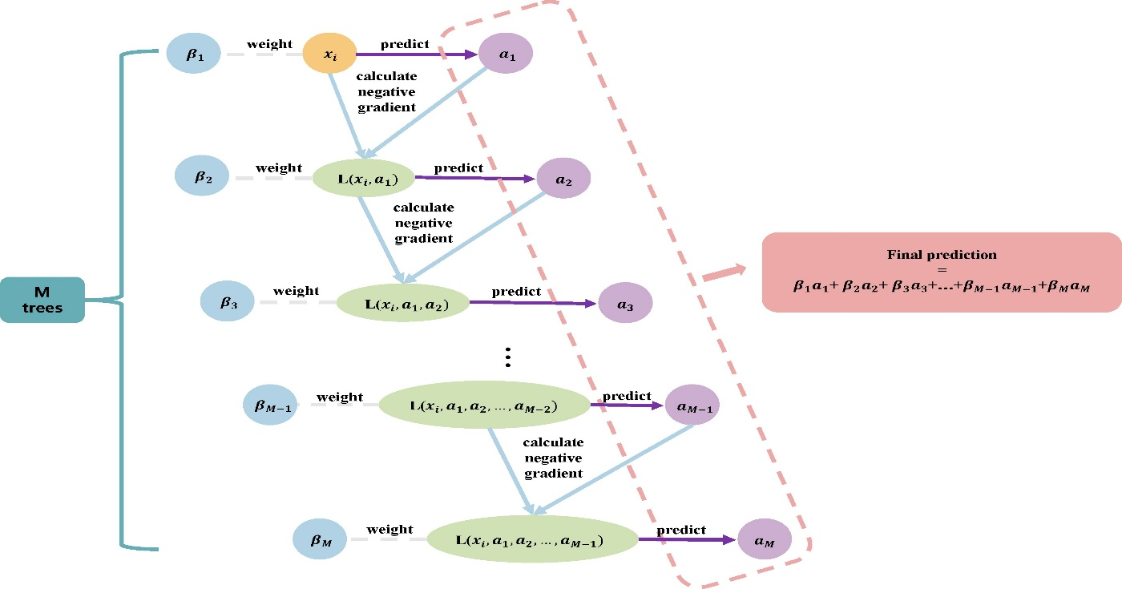

Figure 1: XGBoost Model
The core of the system's workflow is the operation of drivers logging into their account and following the instruction of the route assigned to them. Meanwhile, their GPS data is sent to the backend via secured WebSocket channels continuously. In turn, the backend server is responsible for the data processing and the real-time updates of the commuter and admin dashboards. Through the same system, commuters visualize on a map a live bus location and get estimated arrival times, while administrators receive a complete overview of fleet efficiency are able to prepare reports, and alert themselves in case of deviations and idling. A digital ticketing system is also implemented in this project where passengers have the liberty to purchase tickets on the web interface, make payments with the provision of security, and receive fast receipts. The admin panel is not left behind as it executes the functions of recording every transaction and initiating the generation of automated financial reports for transparent accounting. Such high-level integration of digital techniques is not only efficient in the prevention of human intervention and revenue leakage but also financially sustainable by the virtue of the ​‍​‌‍​‍‌​‍​‌‍​‍‌system.

CUSTOMER/USER PROFILE
The The​‍​‌‍​‍‌​‍​‌‍​‍‌ public transport tracking and management system is a user-centric system with different user communities in mind. Each of them has its unique roles, requirements, and level of

technological adoption. These users are the passengers, drivers, and administrative and regulatory authorities. Each department has its activities through the system by using portals which are functionally efficient and technologically feasible for them. The latter is carried out through first-hand data updating, instantly triggered messages, and encrypted information interchange contributing to the seamless integration of the different players in the public transport sector into a single digital ​‍​‌‍​‍‌​‍​‌‍​‍‌space.

COMMUTERS

Commuters​‍​‌‍​‍‌​‍​‌‍​‍‌ are the major user segment of the system and, thus, they become the direct beneficiaries of its services. This category of users embraces students, office workers, tourists, and everyday passengers who are reliant on public transport for their daily mobility. In the past, these users have had to endure the hardships of situations like irregular schedules, overcrowded buses, and the absence of reliable arrival-time information. The system resolves these problems by offering real-time tracking and AI-based Estimated Time of Arrival (ETA) which are easily accessible through a convenient web interface. Considering that a large number of commuters might lack advanced technical knowledge, the interface focuses on aspects like simplicity, clarity, and accessibility. It permits users up-to-the-minute vehicle locations and the ability to reserve or purchase digital tickets, at the same time, they can receive a prompt notification regarding route changes, delays, or cancellations. Moreover, SMS and email alert capabilities of the system are instrumental in facilitating access to the most important information for residents of remote areas, who may have a low rate of mobile device usage, without requiring them to have a smartphone application. The system through the means of ticketing digitalization and the facilitation of secure online payments, is doing the work of eliminating waiting times as well as cash handling, thus, it is providing a safety and more efficiency in travel experience. On top of that, commuters have the ability to attain personalized panels which will present the histories of the trips as well as the routes that the commuters like together with the opportunity to provide the feedback to improve the quality of the service. In essence, the aforementioned functions become instrumental in building trust among commuters, alleviating their worries, and making everyday commuting predictable, interesting, and also, ​‍​‌‍​‍‌​‍​‌‍​‍‌green.

DRIVERS

Drivers​‍​‌‍​‍‌​‍​‌‍​‍‌ are essentially the heartbeat of the whole transportation network and the main sources of data for the platform. Along with that they are provided a web dashboard through which, they can record their attendance, attest to the routes assigned to them and in turn, locally the GPS data is kept updating the required server. The back-end server gets updates in real-time and this is very instrumental to the system mechanisms of tracking as well as ETA prediction. The driver interface is tailored in a manner that it hardly distracts the driver as it shows just the most significant route and schedule details. Additionally, it equips drivers with the ability to change the status of the journey, communicate in case of a mechanical fault, or quickly send an emergency message to the head office. The system is designed in such a way that it can automatically take the records of departure and arrival times thus in every trip, it is possible to create an audit trail. With the help of automated monitoring and analytics, the entire scheme becomes an instrument in the hands of the administration in gauging driver punctuality, route adherence, and performance consistency. In the long run, the information can be exploited to both incentivize reliability and pinpoint qualification requirements. Therefore, the platform is fostering the notion of transparency not only through the elucidation of daily operations but also through the inculcation of the culture of safety and accountability among the staff that ​‍​‌‍​‍‌​‍​‌‍​‍‌drive.

ADMINISTRATIVE AND REGULATORY AUTHORITIES

The​‍​‌‍​‍‌​‍​‌‍​‍‌ third category includes administrators who are in charge of the everyday transport management and government or municipal authorities that supervise system regulation and long-term planning. Strategically and supervisory, they constitute the core of the project. Administrators manage the system through a centralized control panel of the system, which is an overview of almost everything happening in the network, such as the information of the vehicles, the routes, and the activities of the commuters. Not only that, but they also have the power to make routes, to assign them, to set up the timings of the departures, and also to see the data about the performance of the system in real-time such as fuel consumption, average delay, and passenger density. Plus, the panel also allows the integration of predictive analytics that naturally detects inefficiencies, thus, enables the quick response in the prevention of delays or overcrowding.

Besides, as the most executive level, transport authorities and regulatory agencies besides the

platform along with analytical reports conduct data-driven decisions regarding city-wide transportation policies and infrastructure development. Their job is to find the changes in the that demand such as that in ridership, revenue growth, and the environmental impact, and from their trends, they design sustainable strategies for the future of urban mobility. Striving towards these aims, the system’s ability to provide detailed compliance and performance reports serves as a security measure to guarantee that transport operations conform to government standards and safety norms. The combination of all these strategies and tools gives room for administrators and authorities to easily collaborate just like the implementation of the plan cooperatively between real-time logistics authorities and policymakers. While administrators are active and are executing resources in the field in real-time, policymakers avail themselves of the aggregated data to evaluate long-term outcomes such as energy efficiency, emission reduction, and service accessibility. Bringing together not only the administrative but also the policy side, the system constitutes an open governance structure capable of increasing the public trust, as well as, facilitating the achievement of national goals for sustainable, smart, and inclusive transport by paving the way for ​‍​‌‍​‍‌​‍​‌‍​‍‌it.

FUNCTIONAL REQUIREMENTS
It must accept URL as well as content of the email for input to the system. The system will offer channels through which users can input URLs and text of email content through web-based interfaces or API endpoints for programmatic access. For email content, the system will parse raw text content inclusive of metadata such as headers (for example "From," "Reply-To") and body content, which plays a crucial role in the detection of phishing patterns. In addition, the system will provide enterprise users with bulk submission capabilities to scan very large volumes of emails and URLs in one step, making it more useable for corporate environments.
The system has to analyze submitted content and classify it as being phishing or legitimate. The

primary functionality is processing submitted data based on machine learning (ML) models trained to detect phishing indicators. Analyze domain reputation (e.g., whether the domain has been reported for phishing); URL structure, e.g., some unusual subdomains or misspelled domains; and semantic content analysis of email text, including keywords associated with phishing, such as "urgent" or "verify your account." ML models, such as Random Forests, SVMs, and Neural Networks, will classify input based on patterns learned from historical phishing data. The system will generate the classification probabilities to let it decide what is being scanned to label as phishing and what not.
The system must generate the reports and alerts in detail for detected phishing. During detection of the phishing attempt, the system will prepare a detailed report stored in a centralized logging database for review. This report will include the analysis of indicators such as flagged keywords, domain analysis results, ML classification confidence scores, and other metadata from email headers. Alerts will be raised through an ENS sending notifications to users across channels like the app, SMS, or email through a choice made from the User Profile database based on their preferences. The system will provide a Threat Analysis dashboard to the administrator, which tracks the phishing incidents and response actions. System will be maintained with an updated database of known phishing sites and methods.
The system shall maintain a database of threat intelligence, which will keep updating the information with known phishing URLs, email patterns, and emerging attack vectors. Updates would be acquired from public sources such as PhishTank and Spamhaus and proprietary sources where necessary. Ingestion of updates would be handled through automated ingestion scripts to handle such updates, accompanied by data validation checks to ensure integrity. Such databases would regularly be retrained on this model using the provided updates, thereby adapting the ML models to new phishing tactics, which would help decrease false positives while increasing the detection accuracy over time.

NON-FUNCTIONAL REQUIREMENT

The​‍​‌‍​‍‌​‍​‌‍​‍‌ non-functional requirements are the features that tell the Public Transport Tracking and Management System how to perform instead of what to perform. These attributes make sure that the system is not only correct in its functioning but also that it is efficient, scalable, reliable, and user-friendly to a high degree. As this system is going to be used in real-time scenarios with maybe thousands of users accessing it simultaneously, these non-functional factors are of utmost

importance for its accomplishment. The next subsections briefly describe the significant non-functional requirements of the ​‍​‌‍​‍‌​‍​‌‍​‍‌undertaking.

    - SCALABILITY:

The​‍​‌‍​‍‌​‍​‌‍​‍‌ system has to be capable of extending its capacity both on a level of different devices and on a single level of device in situations where there is a demand for a larger amount of data or users. Transport networks in metropolitan and semi-urban areas that rely on GPS can be a source of very large volumes of data because of nonstop GPS transmissions, ticketing operations happening concurrently, and requests for real-time analytics. To meet such requirements, the system should be implemented in the cloud, for example, on AWS, Azure, or Google Cloud, thus enabling the automatic allocation of additional computing resources during the hours of great load.

By the employment of horizontal scaling, several servers or containers will be able to work together, thus responding to the requests from users for services like backend API, frontend client, and AI microservice, in a balanced manner. Load balancing techniques will be at work so that the performance of a single node will not be a bottleneck. Vertical scaling will enable the use of more powerful virtual machines or compute instances when data processing demands increase, for example, during large public events or system-wide updates.Scalability architecture must be such that it not only ensures system stability but also guarantees consistent performance in the face of an exponential number of users or vehicles being tracked. Simply put, scalability is the system's ability to perform its functions without any interruptions even when there is a dramatic increase in data and ​‍​‌‍​‍‌​‍​‌‍​‍‌users.

BEING RELIABLE AND ACCURATE

Reliability​‍​‌‍​‍‌​‍​‌‍​‍‌ and accuracy essentially constitute what the Public Transport Tracking and Management System stands for, as it is a platform that is supposed to provide services that are both trustworthy and uninterrupted to the users and authorities alike. The system is scheduled to have a 99.9% uptime rate, with very few instances of service interruptions. In order to realize this objective, it will be deploying redundant databases, replicated servers, as well as automatic failover mechanisms that will be able to switch operations to another component without delay when the main component is failing.

As a matter of fact, the accuracy is that important, especially for features that are heavily dependent on time, i.e. ETA prediction and route tracking. In order to have accurate results, the AI models have to be re-trained continuously with up-to-date transport and traffic data. The system is going to rely on the past travel logs, the live GPS signals, and the surrounding factors like congestion levels or weather conditions to come up with more accurate predictions. The on-the-fly retraining of the model drastically reduces the number of prediction errors and ensures that the arrival times that are communicated are actually the closest possible to the real ones. Through the use of a blend of fault-tolerant architecture and intelligent learning models, the system makes it possible for the users to be in receipt of both regular services and up-to-date information — hence, the platform being dependable even under complicated and unpredictable transport ​‍​‌‍​‍‌​‍​‌‍​‍‌scenarios.

PERFORMANCE AND TIME OF RESPONSE

It​‍​‌‍​‍‌​‍​‌‍​‍‌ is a must that the system provides users with updates and feedback almost instantly in order to keep them engaged in the experience without interruptions. The application takes in sizable data streams from several sources — GPS signals, payment gateways, and user interactions — thus the target response time for displaying updates or recalculating ETAs should be less than two seconds under normal network conditions.

It is planned that the backend will through asynchronous request handling and data caching strategies achieve this goal. Data that is frequently accessed, for instance, route maps or fare tables will be cached in memory so as to minimize database queries. A few lightweight AI models will be employed for faster prediction during live operations whereas heavy training

processes will be carried out asynchronously in the background. In addition, optimization of database queries and API load balancing will be the means to go performance-wise during high traffic volumes thus not slowing down the system. This real-time responsiveness is, therefore, very important to keep commuter trust and to make sure that transport authorities are able to make timely operational ​‍​‌‍​‍‌​‍​‌‍​‍‌decisions.

USABILITY:

How​‍​‌‍​‍‌​‍​‌‍​‍‌ users interact with the platform is essential for the platform to be used by a wide range of users, e.g., non-technical commuters, and field-level drivers. The system interface should be intuitive, user-friendly, and available on all devices — desktops, tablets, and mobile phones. The design will adhere to responsive web standards, thereby it will change layouts automatically to fit different screen sizes and resolutions. The visual aspect will be kept clear by using a minimalistic design, simple navigation menus, and clear data visualization on dashboards.

Users must be able to carry out route lookup, ticket booking, and alert viewing, which are all very important operations, without having any prior technical experience. The admin dashboard will have various interactive charts and reports that will be easy to understand because they will have the right visual cues. Regarding security, the platform has to protect all sensitive data with the help of AES-256 encryption for data storage and TLS/SSL encryption for data transmission. The authentication will be done through JWT (JSON Web Tokens), thus only verified users will be allowed to access role-specific functions. Besides that, security audits and vulnerability assessments will take place regularly to find and solve the issues that may cause data breaches or unauthorized access. In other words, usability and security will be the reasons why the system will still be a safe place for all users yet easily accessible to ​‍​‌‍​‍‌​‍​‌‍​‍‌everyone.

MAINTAINABILITY:

It​‍​‌‍​‍‌​‍​‌‍​‍‌ is a must that the system architecture be modular and planned in such a way that it could be easily maintained, debugged, and extended. Every component — whether it is doing input processing, AI prediction, ticketing, or alerting — will be developed as an independent service, thus, developers will be able to update or replace one part of the system without the rest being affected. This microservices-inspired structure, which is aimed at maintainability, also allows for less downtime during system upgrades or bug fixes.

Documentation will be made for all the code, APIs, and deployment procedures so that developers in the future or the teams responsible for the maintenance will have an easy time understanding the dependencies and workflows. Continuous integration and deployment (CI/CD) pipelines will be implemented to facilitate testing and updating, thus, patches or new features can be rolled out quickly and safely. Moreover, the system should enable administrators to carry out maintenance operations like removing old logs, retraining AI models, and checking container health through a single control interface. Maintainability is the feature that makes the system remain viable and eco-friendly in the future, even when the technology ​‍​‌‍​‍‌​‍​‌‍​‍‌changes.

COMPLIANCE:

The​‍​‌‍​‍‌​‍​‌‍​‍‌ Public Transport Tracking and Management System should be aligned with both regional and international data protection laws so as to be able to handle user information in a responsible manner. It shall be mandatory to comply with such regulations as the General Data Protection Regulation (GDPR) and the California Consumer Privacy Act (CCPA) in order to provide that users are the ones who keep control over their personal data.

Firstly, the system shall offer privacy policies available to all users and clearly explaining the processing of user data (e.g., location history or payment information) that is collected, stored, and used. Every user must have the possibility of accessing, editing, or erasing their personal data upon receiving the request. The agreeing mechanisms will be set up in the registration phase so that users are very clear about the fact that they permit their data to be used for operational or analytical purposes.

Aside from that, the program should also remove identifiers from the sensitive information before it is used in AI training or reporting. This is to ensure that ethics are followed while at the same time, analytical accuracy is not compromised. The organization will also conduct regular compliance audits to ensure that privacy, transparency, and consent requirements are always fulfilled. By embracing security, maintainability, and ethical data management as core principles, the Public Transport Tracking and Management System creates the conditions for a safe, transparent, and sustainable digital ecosystem that has the capacity to serve millions of commuters ​‍​‌‍​‍‌​‍​‌‍​‍‌reliably.

DESIGN:

3.1. E-R DIAGRAM
An​‍​‌‍​‍‌​‍​‌‍​‍‌ Entity–Relationship (E–R) diagram depicts the comprehensive logical data model and the interrelations of the principal entities that are the part of the Public Transport Tracking and Management System. The primary entities of the system are User, Driver, Admin, Vehicle, Route, Trip, and Booking. Every entity is like a separate organ of the body, and their communication is like that of neurons between the brain and other organs, i.e., the relation between commuters, drivers, and administrators through the ​‍​‌‍​‍‌​‍​‌‍​‍‌entities.
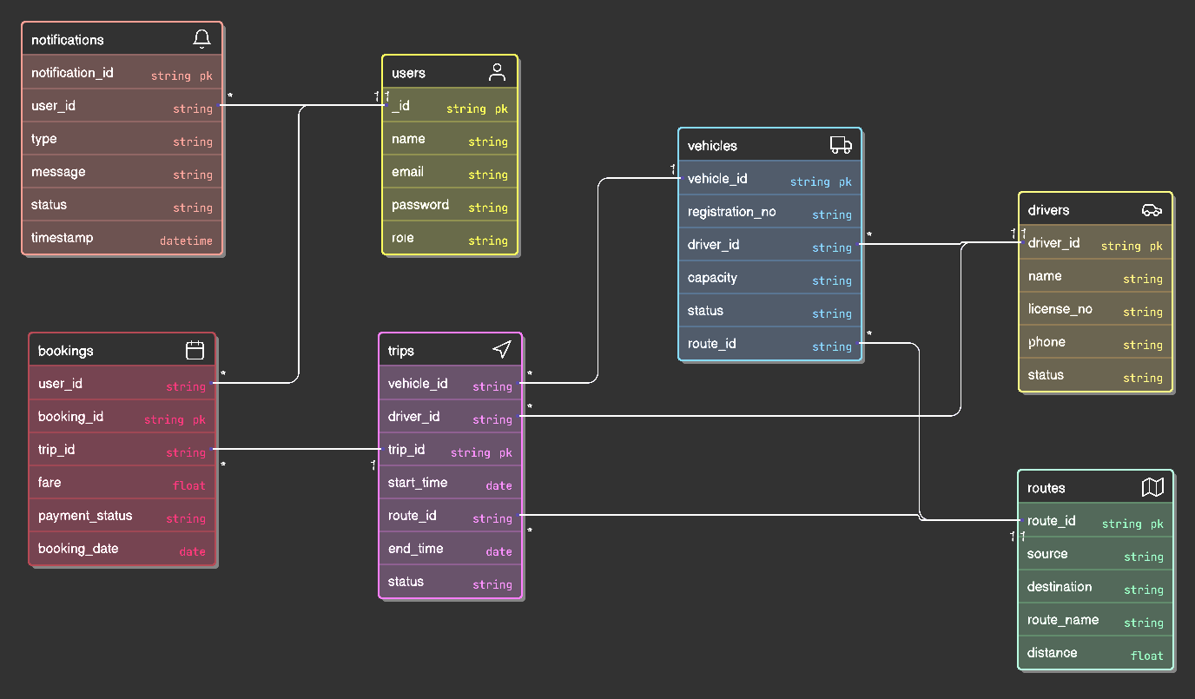

Figure 4: E-R diagram

User​‍​‌‍​‍‌​‍​‌‍​‍‌ is the main entity and thus can be considered as the major focus of the system or the application. They can book tickets, watch live vehicle status, and receive alerts. Driver details such as assigned vehicles, route status, and trip updates are recorded by the Driver entity. Admin accounts have access to all levels of the organization and hence the most extensive control - among others, they can manage the allocation of routes and vehicles, performance and analytics monitoring.

Vehicle and Route are two different entities that are intertwined together, describing the operational infrastructure of the system-vehicles being assigned to routes and managed both based

on schedules and real-time data. A Trip is an entity that connects drivers, vehicles, and routes while Booking is a means of linking users to trips via digital ticketing and payment. The diagram has also some other entities i.e. Notification, ETA Model, Crowd Model, and Anomaly Model which are the intelligent layers of the system. These modules utilize AI-driven predictions for travel time, passenger density estimation, and anomaly detection. The relationships represented here are a comprehensive data model that serves as the backbone of the transport operations which are still ongoing and centrally managed in real-time throughout the ​‍​‌‍​‍‌​‍​‌‍​‍‌network.

3.2 DATA FLOW DIAGRAM

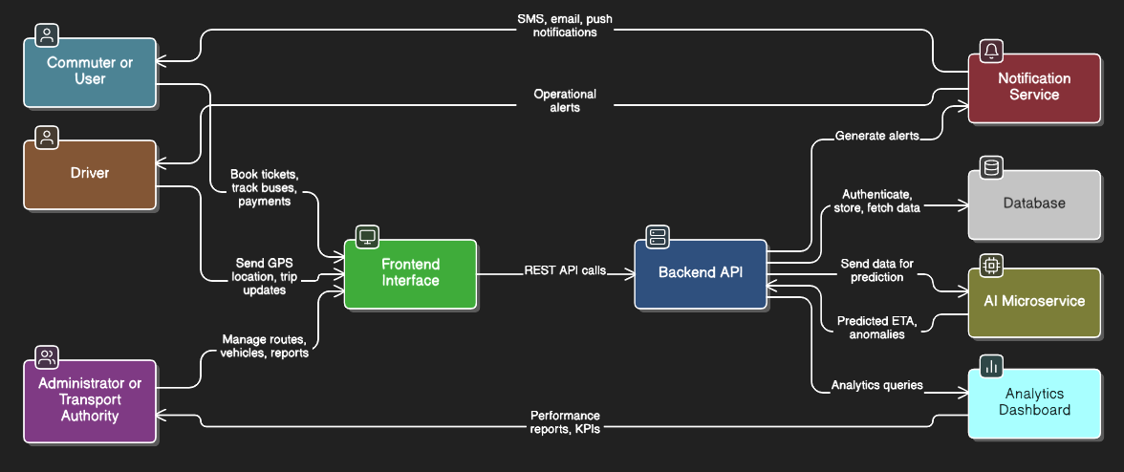

Figure 5: Data flow diagram

The​‍​‌‍​‍‌​‍​‌‍​‍‌ Data Flow Diagram (DFD) shows the major data movement stages in the Public Transport Tracking and Management System, including the flow of data between the external users and the internal modules. It explains the user operations flow of the logical system that links the frontend, backend, and AI parts to the commuters, drivers, and administrators.

Users provide inputs using a web-based interface by searching for routes, viewing bus live locations, and booking tickets. Drivers serve as input sources as well, sending live GPS data and trip status updates through the driver interface. The admin or transport authority, on the other hand, provides the vehicle details, route information, and scheduling inputs as configuration data. These requests and updates are handled by the backend API, which also performs operations such as ticket booking, user authentication, and trip management by working with the central MongoDB database. Furthermore, the backend communicates with the AI microservices to ETA estimations, route pattern anomaly detection, and crowd density estimation. The notification subsystem is pushing the alerts to users like delay updates or trip confirmations, and the analytics module provides administrators with performance reports and decision-making insights. The DFD documents the information exchanges and control flow between the various agents and the subsystems, thus ensuring that the system is efficient, transparent, and ​‍​‌‍​‍‌​‍​‌‍​‍‌scalable.

3.3 DATABASE DESIGN

The​‍​‌‍​‍‌​‍​‌‍​‍‌ Public Transport Tracking and Management System database design outlines the entities' structures, attributes, and relationships within the platform. It specifies a unified data model for recording, managing, and fetching all the vital pieces of information concerning users, vehicles, routes, trips, bookings, and system notifications. The database is designed with normalization standards to reduce redundancy and keep data consistency across different modules.

The backend database of the system is based on MongoDB, which provides the required flexibility and scalability to accommodate the data that need to be updated in real-time like GPS coordinates, trip statuses, and user interactions. Every collection (table) in the database has its own distinct function and at the same time maintains relationships with other collections through foreign key references and logical ​‍​‌‍​‍‌​‍​‌‍​‍‌mapping.

USERS TABLE
It stores user authentication and profile details. The table keeps records of commuters, drivers, and administrators with their respective roles, email addresses, and encrypted passwords. It also tracks user status and registration timestamps to ensure secure access management and system accountability.
Primary key: user_id

VEHICLES TABLE
This table maintains all registered vehicles in the transport system. It stores details such as registration number, model, capacity, and operational status. Each vehicle is linked to an assigned driver and route for active trip tracking.
Primary key: vehicle_id
Foreign keys: driver_id, route_id

ROUTES TABLE
This table captures information about every defined route in the system, including the route name, source, destination, total stops, and travel distance. It provides data for trip scheduling, route optimization, and AI-based ETA calculations.
Primary key: route_id

TRIPS TABLE
The Trips table records all ongoing and completed bus trips. Each trip is associated with a specific driver, vehicle, and route. It includes timestamps for start and end times, trip status, and distance covered. This table plays a central role in real-time monitoring and historical data analysis.

Primary key: trip_id
Foreign keys: driver_id, vehicle_id, route_id

BOOKINGS TABLE
It stores all user booking transactions and ticketing details. Each booking entry links a user to a specific trip and includes information such as seat number, booking date, fare, and payment status. This table enables secure digital payments and user access to trip details.
Primary key: booking_id
Foreign keys: user_id, trip_id

NOTIFICATIONS TABLE
This table maintains alerts and system-generated notifications for users and drivers. Notifications include trip confirmations, delays, cancellations, or administrative announcements.
Primary key: notification_id
Foreign key: user_id

AI MODELS TABLE
This table integrates with AI subsystems to store machine learning results such as predicted ETA, crowd density, and anomaly detection outputs. It links with trips and routes for analytical insights used by the admin dashboard.
Primary key: model_id
Foreign keys: route_id, vehicle_id

ADMINS TABLE
It stores information about system administrators who manage vehicles, routes, and users. This table records administrative actions, privileges, and access levels. Audit trails from this entity help in monitoring system performance and ensuring operational transparency.
Primary key: admin_id

KEY DESIGN PRINCIPLES
Normalized Structure: Each table is normalized to avoid redundancy and improve query performance.
Relationship Mapping: Logical relationships connect users, bookings, routes, and vehicles for data integrity.

Comprehensive Tracking: Every entity maintains metadata such as timestamps, statuses, and references for monitoring.
Scalability: Designed to handle growing datasets, especially real-time GPS and booking transactions.
Security: User credentials and payment details are stored in encrypted form for secure access control.
Integration Support: AI model outputs and analytics reports are seamlessly linked to operational entities.

RELATIONSHIPS
Users can make multiple bookings.
Vehicles can be assigned to multiple trips over time.
Routes can have multiple vehicles and trips.
Each trip connects a driver, vehicle, and route.
Admins can manage multiple routes, drivers, and notifications.
AI models continuously update ETA and crowd analytics for ongoing trips.

RESULTS

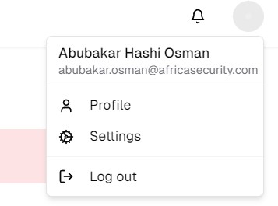

Figure 7: Login page and settings

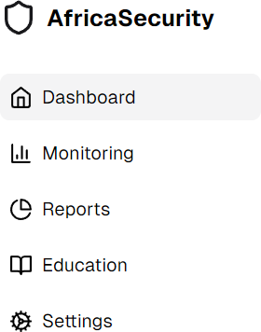

Figure 8: Dashboard

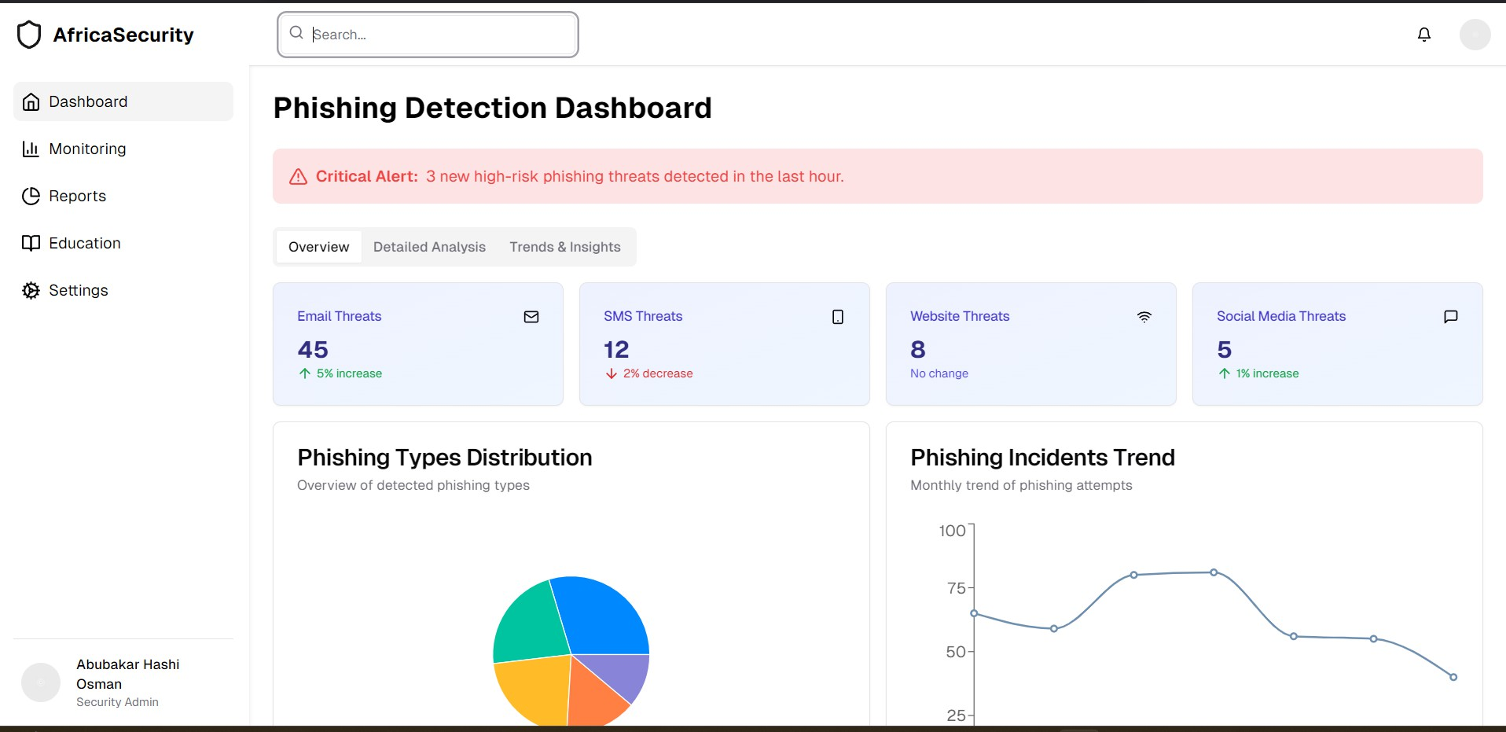
Figure 9: General layout of the website

SCHEDULING AND ESTIMATES
This project is divided into several phases that involve the tasks performed and the time line it takes to perform each of them.
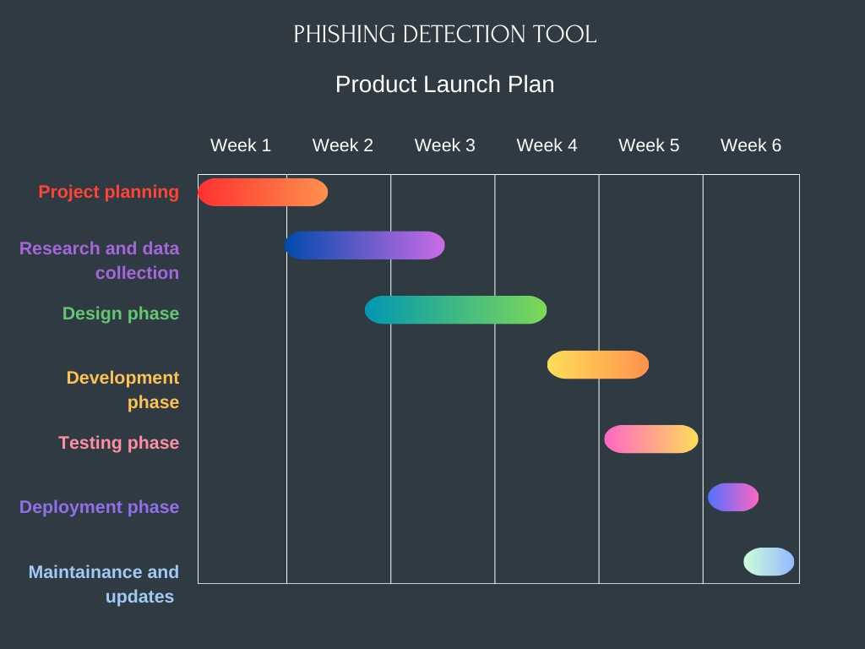

Figure 10: Scheduling diagram

Project Planning

In this initial phase, project goals are defined, the system’s scope is determined, and each team member is assigned a specific role. The foundation of the architecture, scheduling, and workflow dependencies is established.

Research and Data Collection

During this phase, relevant datasets and transport information are collected. This includes analyzing bus routes, GPS logs, passenger flow data, and studying existing smart transport solutions. These datasets form the foundation for AI model training and route optimization

algorithms.

Design Phase

System architecture and database schemas are finalized in this stage. The team designs the user interface for the commuter, driver, and admin portals, ensuring ease of use and responsive layouts. The backend API flow, microservices integration, and AI components are also outlined.

Development Phase

This is the most intensive phase where all major system components are implemented. The backend, developed using Node.js and Express, connects to MongoDB for real-time data storage. The frontend, built using React.js and Mapbox, enables live bus tracking and booking. Meanwhile, the AI microservice (FastAPI + TensorFlow) handles ETA prediction and anomaly detection. All modules are integrated and tested for consistency.

Testing Phase

Both unit and integration testing are conducted to validate the system’s logic, functionality, and API connections. Stress and performance tests are performed to ensure scalability under real-time load conditions. All issues are resolved before deployment.
Deployment Phase

In this stage, the system is containerized using Docker for efficient deployment across environments. The live server is configured, and the system undergoes final user acceptance testing (UAT) to ensure stable and reliable performance.

Maintenance and Updates

Post-deployment, regular maintenance and updates are conducted. AI models are retrained periodically using new transport data, and new features are added based on stakeholder feedback. This ensures that the platform remains scalable, secure, and future-ready.

REFERENCES
- https://www.researchgate.net/profile/Rishikesh-Mahajan/publication/ 328541785_Phishing_Website_Detection_using_Machine_Learning_Algorithms/links/ 5d0397fd92851c9004394af4/Phishing-Website-Detection-using-Machine-Learning- Algorithms.pdf
- Ankit Kumar Jain, B. B. Gupta: Towards detection of phishing websites on client-side using machine learning based approach: In Springer Science+Business Media, LLC, part of Springer Nature 2017
- https://medium.com/@mathparracho/autoencoders-and-latent-space-studying-their- power-for-data-compression-7f6b59d9694b
- https://medium.com/low-code-for-advanced-data-science/support-vector-machines-svm- an-intuitive-explanation-b084d6238106
- Kang Leng Chiew, Kelvin Sheng Chek Yong, and Choon Lin Tan. A survey of phishing attacks: Their types, vectors and technical approaches. Expert Systems with Applications, 106:1 – 20, 2018
- https://www.researchgate.net/profile/Er-Purvi-Pujara/publication/ 331198983_Phishing_Website_Detection_using_Machine_Learning_A_Review/links/ 5c6bd4ae4585156b5706e727/Phishing-Website-Detection-using-Machine-Learning-A- Review.pdf
- Scikit modules: https://scikit-learn.org/stable/
- Priya, D. Gutema and S. Singh, "A Comprehensive Survey of Recent Phishing Attacks Detection Techniques," 2024 5th International Conference on Innovative Trends in Information Technology (ICITIIT), Kottayam, India, 2024, pp. 1-6.
- Alkhalil, Z., Hewage, C., Nawaf, L., Khan, I.: Phishing attacks: a recent comprehensive study and a new anatomy. Front. Comput. Sci. 3, 563060 (2021)
https://www.occ.gov/topics/consumers-and-communities/consumer-protection/fraud- resources/phishing-attack- prevention.html#:~:text=Never%20provide%20personal%20financial%20information,tha t%20can%20contaminate%20your%20compute

- r.

